**Activity Diagram**

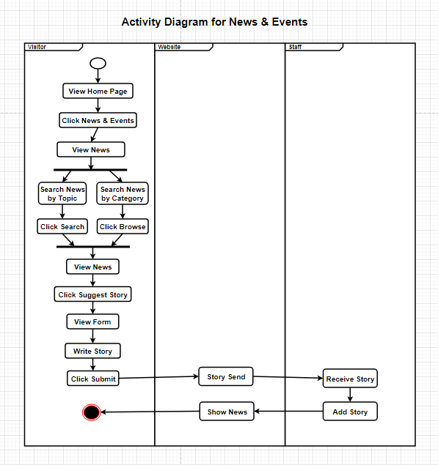

**Figure: Activity Diagram for News & Events of Monash University**

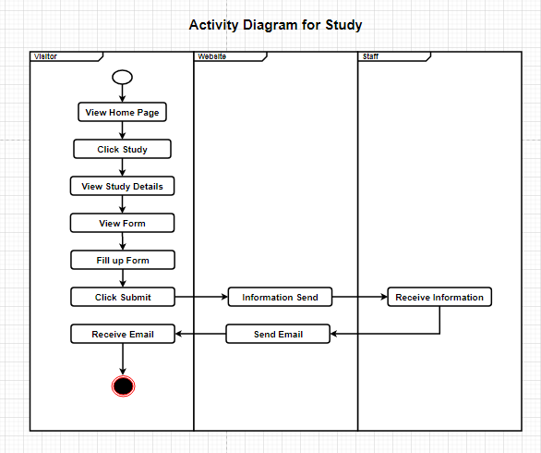

**Figure: Activity Diagram for Study of Monash University**

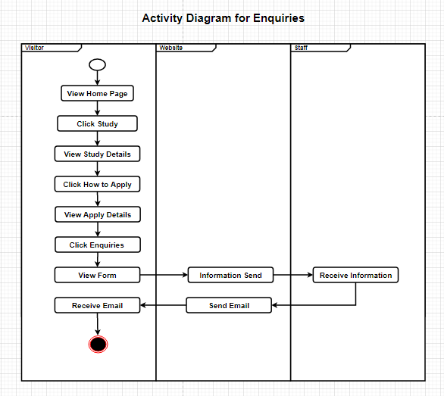

**Figure: Activity Diagram for Enquiries of Monash University**